United Church of God Ministries, Incorporated International

2021 Seven Triumphant Church Growth Imperatives:

I. Grow the kingdom of God by Soul Winning
References:
- John 3:3 …except a man be born again, he cannot see the kingdom of God.
- John 15:16 …God had chosen and ordained us to go and bring forth fruit.
- Matthew 28:19 … we are to go and teach all nations, baptizing them in the name of the Father, and of the Son and of the Holy Ghost.
- Mark 16:15 … we are commanded to go into all the world and preach the Gospel
- Galatians 6:7-8 …we shall reap what we sow..
- Luke 14:23 …go out into the highways and hedges, and compel them to come in, that my house may be filled.
- Acts 2:21 …whosoever shall call on the name of the Lord shall be saved.
II. Grow Leaders to be Mentors
References:
- 2 Timothy 2:2 …we are to teach others about Jesus Christ
- Proverbs 27:17 …we need to sharpen each other’s countenance
- Proverbs 22:6 … we train up a child in the way he should go..
- Titus 2:3-4 …Older women to teach the younger women to be sober and love their husbands and children.
- I Thessalonians 2:8 …we are to impart wisdom and knowledge to others
III. Growth In Spiritual Maturity by studying Biblical principles and precepts.
References:
- James 1:22-25 …we need to be doers of the Word and not hearers only.
- Ephesians 4:11-15 …we are to obey what God had called us to do – apostles, prophets, evangelists, pastors, and teachers – for the perfecting.. work and edification of the body… speaking the truth in love … so that we may GROW up into Him in ALL things..
- I Peter 2:2 …we need to desire the sincere milk of the Word in order to grow.
- I Peter 2:1-25 (teach the entire chapter)
- II Peter
IV. Grow our personal relationship with God by reading the entire Bible and devoted time in prayer.
References:
- Acts 17:27 … seek the Lord
- John 1:2 …we need to begin our day with God
- Hebrews 4:12 …The Word of God is quick and powerful, and sharper than any twoedged sword, piercing een to the dividing asunder of soul and spirit, and of the joints and marrow, and is a discerner of the thoughts and intents of the heart.
- Hebrews 13:5 …we offer the sacrifice of praise to God continually… the fruit of our lips giving praise to his Name.
- 2 Timothy 3:16-17…All scriptures is given by inspiration of God… profitable for doctrine, for reproof, and correction, and for instruction in righteousness: that the man of God may be perfect, thoroughly furnished unto all good works.
V. Grow to enhance relationship with others; Start within the Family Unit.
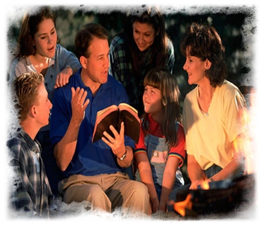
References:
- Matthew 22:34-40 …we are to love our neighbors as ourselves.
- Romans 12:18 …we are to live peaceably with ALL men.
- Colossians 3:5-13 …put on the new man…renewed in knowledge after the image of Him that created us – put on, as the elect of God, holy and beloved, bowels of mercies, kindness, humbleness of mind, meekness, longsuffering, forbearing one another, and forgiving one another.. put on love – it is the bond of perfectness.
VI. Grow to Lead the Church in Community Projects/Activities
References:
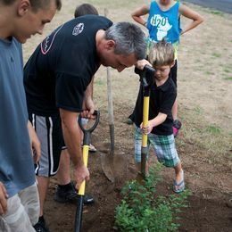
- Hebrews 10:24-25 …we are encourage to assemble
- Galatians 6:2…we are to bear one another’s burdens to fulfill the law of Christ.
- Romans 12:3-13 …we are encourage of not just think of ourselves, we ought to think about other members.
- Galatians 6:10…whenever we have the opportunity, we need to do good to everyone.
- Matthew 25:35 …we need to demonstrate giving to others – food, drink, and welcome.
- Isaiah 61:1-4 …God had anointed us to bring good news to the poor
This Photo by Unknown Author is licensed under CC BY-SA

VII. Grow in Church Evangelization and Outreach.
References:
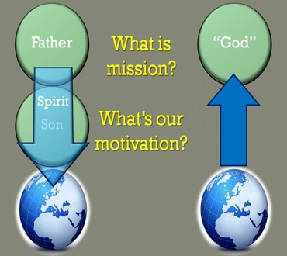
- Romans 10:14-15…we are to go out and share Christ - go preach.
- I Chronicles 16:23-25 …we are to declare His glory among the nations, his marvelous deeds among all people.
- John 4:35-36…we need to open our eyes and look at the fields.. they are ripe for harvest… the sower and the reaper may be glad together.
- John 17:20-24 …God is in us…. The world will believe that we are God-sent.
- I Peter 3:15 …we need to always be prepared to give an answer to everyone who asks a reason for the hope that we have – this must be done with gentleness and respect keeping a clear conscience.

2021 Education and Discipleship
Emily-Joy P. Flynn, CEA
United Church of God Ministries, Inc.
Headquarter Office
2808 West Temple Street
Los Angeles, CA 90026

